**Project I**

1. As shown in below picture, build the network topology using the packet tracer file and do the following instructions for configuring VPN between Router 0 and Router 1.

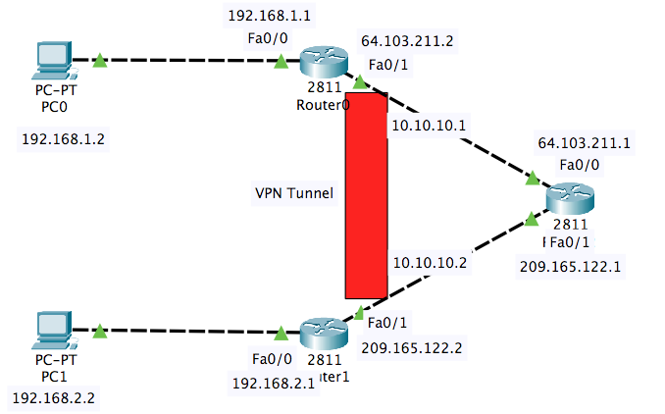

1. Set up IP addresses for each device.

|  |  |  |  |  |
| --- | --- | --- | --- | --- |
| Device | Interface | IP address | Subnet Mask | Gateway |
| PC0 | Fa0 | 192.168.1.2 | 255.255.255.0 | 192.168.1.1 |
| PC1 | Fa0 | 192.168.2.2 | 255.255.255.0 | 192.168.2.1 |
| Router0 | Fa0/0 | 192.168.1.1 | 255.255.255.0 | NA |
| Fa0/1 | 64.103.211.2 | 255.0.0.0 | NA |
| Router1 | Fa0/0 | 192.168.2.1 | 255.255.255.0 | NA |
| Fa0/1 | 209.165.122.2 | 255.255.255.0 | NA |
| Router2 | Fa0/0 | 209.165.122.1 | 255.255.255.0 | NA |
| Fa0/1 | 64.103.211.1 | 255.0.0.0 | NA |

1. Configure default routing on Router0:

Router0>enable

Router0#config t

Router0(config)#ip route 0.0.0.0 0.0.0.0 64.103.211.1

Configure default routing on Router1:

Router1>enable

Router1#config t

Router1(config)#ip route 0.0.0.0 0.0.0.0 209.165.122.1

1. Check the connection by pinging each other for Router0 and Router1

Router0#ping 209.165.122.2

Router1#ping 64.103.211.2

1. Create VPN tunnel on Router0

Router0#config t

Router0(config)#interface tunnel 10

Router0(config-if)#ip address 10.10.10.1 255.255.255.252

Router0(config-if)#tunnel source fa0/1

Router0(conig-if)#tunnel destination 209.165.122.2

Router0(config-if)#no shut

Create VPN tunnel on Router1

Router1#config t

Router1(config)#interface tunnel 10

Router1(config-if)#ip address 10.10.10.2 255.255.255. 252

Router1(config-if)#tunnel source fa0/1

Router1(config-if)#tunnel destination 64.103.211.2

Router1(config-if)#no shut

1. Check the VPN connection by pinging each other for Router0 and Router1

Router0#ping 10.10.10.2

Router1#ping 10.10.10.1

1. Create routing for PCs to connect over VPN

Router0(config)#ip route 192.168.2.0 255.255.255.0 10.10.10.2

Router1(config)#ip route 192.168.1.0 255.255.255.0 10.10.10.1

1. Check the connection of PC0 and PC1 by pinging each other.

PC0: ping 192.168.2.2

PC1:ping 192.168.1.2

*Submit the screenshots of ping results for step 4, 6, 8 together with your packet tracer file.